Beef Classification & Conformation
Farmers get paid for the quality of their animals based on the breed, conformation & fat class. The higher the quality the animal, the more the farmer gets paid for the animal.

Key terms:
Conformation | LWG (Liveweight gain) | ADG (Average Daily Gain) | Fat class
Fat - class | Graded | Distribution | Shape

Conformation – muscle distribution (shape) on an animal
Beef animals’ conformation is a measure of the shape of the animal and where more of its muscles are located. It is graded according to the EUROP scheme. With “E” being the best & “P” being the worst grade. Higher grades mean that the animal has more muscle in more valuable areas.
The highest value cuts of meat from an animal are located from the middle of the back to the animal’s rear (steaks and roasting cuts).

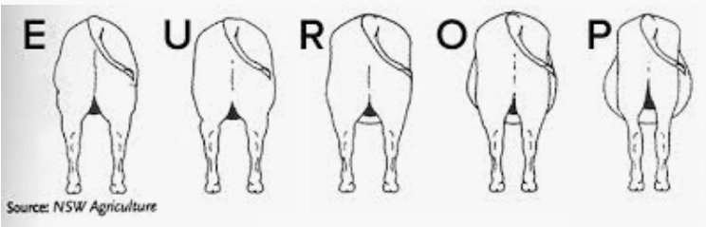

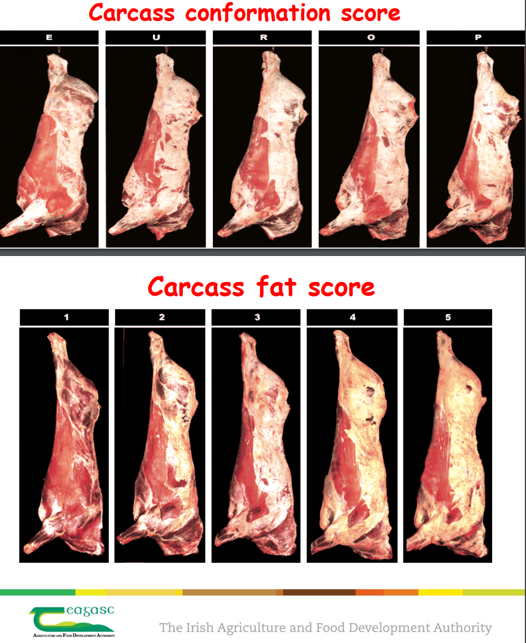

Fat score
Animals are also graded according to their fat class on a scale from 1-5.
1 = very thin, 5 = very fat. 3 ideal fat class.

Kill Out %
The killing-out percentage (KO%) determines how much saleable carcass weight is obtained from the live animal. It is expressed as the weight of the carcass in relation to the weight of the live animal immediately before slaughter. When an animal is slaughtered the hide, internal organs, head and hooves are removed. The carcass is the meat, fat and bone that remains.
The target should be about 50% for dairy beef and often more than 60% for suckler beef. Farmers not recording weights cannot work out the KO%.
KO% can be affected by gut fill, with grazed cattle often having a lower KO% as they will have a larger gut fill compared to an animal fed an energy-dense diet.
Bulls will also have a higher KO% compared to heifers. Remember this when comparing figures.

$(\frac{Animal carcass weight (KG)}{Animal Live weight (KG) })x100$= KO%

ADG (Average Daily Gain)
ADG is a measure of how much weight an animal gains each day of its life from birth. It can be calculated by taking the animals current weight minus its birth weight and dividing that by the number of days old the animal is.

Cattle remittance sheet

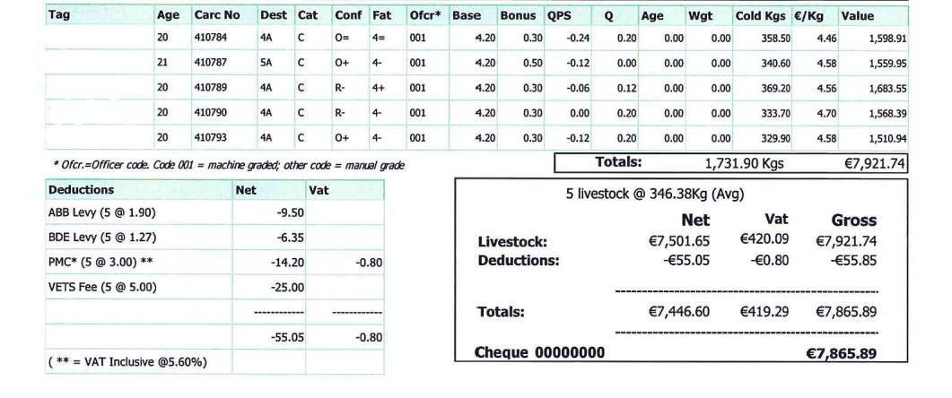
The following is a copy of a remittance sheet that a farmer receives after they send animals to the factory. It documents all the information about their cattle for a farmer.
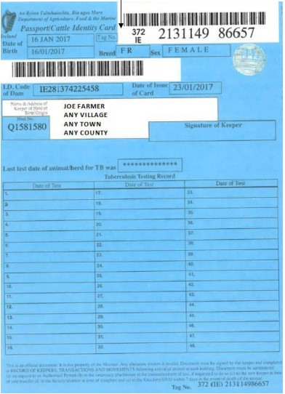
Figure 1 Animal passport
Tag Number
This is the number on the Yellow/White ear tag that identifies the animal. This number matches with the animal passport (Sometimes called “Blue Card” by farmers). This passport contains information about the animal such as it’s breed, the dam’s breed & tag number and the name, address, and herd number of the breeder of the animal. The back of the card includes space for the details of additional owners of the animal. Each time the animal is moved into a new herd, these details should be recorded.

Carcass Number
When an animal enters the factory the ear tags are removed, and a carcass tag is created and attached to the animal carcass. This number is used to trace the animal back to the farm it was born on. This ensures the animal can be traced from farm to fork.
Cat
This stands for category. This refers to the type of animal
Z = young bull (Under 16 months), A = bull, B = Old Bull (Over 36 Months) C = steer D = Cow and E = heifer.

Cold wgt KG
This is the carcass weight of the animal once the offal has been removed. Offal is the belly, liver, lungs, heart, intestines.

Base price
This is the price per kilo, prior to the addition of any of the following bonus’ This price is reported in the farming media and on the Department of Agriculture website each week.
QA “In Spec” bonus
- The Bord Bia Quality Assurance Bonus is paid to qualifying animals. To qualify:
- Steers & heifers must have been on SBLAS approved farm(s) for at least 70 days continuously prior to slaughter.
- Cattle have been a minimum of 60 days on the last SBLAS farm.
- Cattle have a maximum of 4 farm residencies.
- Grade above an O= and between 2+ and 4=.
- A 20c/kg bonus is paid on animals that qualify under this criteria and are U30 months and 8c/kg for animals between 30-36 months.
- Animals that meet all the criteria but are a O- and/or 4+ and under 30 months will get 12c/kg.
QPS Grid
The QPS is the addition/penalty from the base price. It is calculated by the grade and fat score. The chart below depicts the cent per kilo applicable. If an animal grades as a R+4= then they will get an additional 6c/kg added to the base price. An animal that grades O=4- would receive a penalty of 18c/kg that would be subtracted from the base price.

Angus Bonus
The Angus bonus is paid on qualifying animal that meet the Certified Irish Angus inspection criteria in ABP & Kepak factories. In order to qualify, animals must;
- Be from a QA herd & meet the QA in spec under 30 months criteria
- Sired by a pedigree Angus bull
- Meet the Angus visual inspection criteria.
- Identify as AA or AAX on their passport
- Carcass weight 240kg-380kg

Useful resources
- Virtual Beef classification https://virtualbeefandlamb.ahdb.org.uk/index.php
- QA Grid and bonuses sheet Certified Irish Angus Premium Sheet.pdf
- Animal tag/passport rules and list of cattle breed abbreviations https://food.ec.europa.eu/system/files/2017-07/id_bovine_eartag_irl.pdf

Example
A farmer kills an Angus Heifer in the factory. The animal is 23 months old and has a dead weight of 320kg and graded as R+3=. The farm is QA assured and the animal meets the residency and weight requirements. The beef base price is €4.85/kg and the Angus bonus is 10c/kg. What does the farmer receive for this animal?
Animal weight |  | 320kg
Base price | 4.85/kg
+ QA bonus | +0.20c/kg
+ QPS grid | +0.06c/kg
+ Angus bonus | +0.10c/kg
€ Kg price |  | €5.21c/kg
Price paid to farmer |  | €1667.20

Exercise
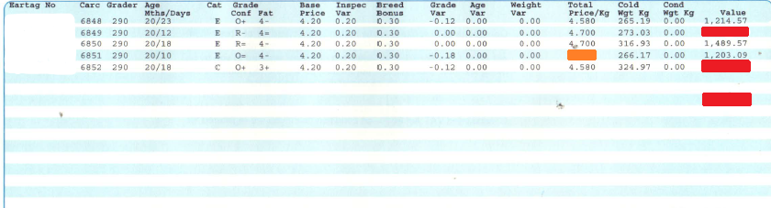

- If the animal 6848 had a live weight of 510kg the kill out % would be 51.9%.
Assuming an animal liveweight of 630kg, calculate the kill out % for animal carcass no. 6850 & 6852.

- Calculate the total price kg for animal carcass no 6851. Based on the figures above, calculate the value of all of the animals this farmer sent to slaughter.

- Based on the figures above, calculate the value of all the animals this farmer sent to slaughter.

